TASK 07: AI Tool Adoption Trend Analysis
1. Problem Statement
The objective of this project is to analyze AI adoption trends across organizations and evaluate the impact of AI on productivity, employee satisfaction, revenue growth, and operational efficiency. The study aims to identify adoption patterns, organizational differences, and business benefits associated with AI implementation.

2. Dataset Description
Dataset Name: Global AI Adoption and Workforce Impact Dataset
Total Records Analyzed: 10,000
Total Features: 43
Important Attributes:
- Industry
- Company Size
- Number of Employees
- AI Adoption Rate
- AI Adoption Stage
- AI Primary Tool
- Employee Satisfaction Score
- Productivity Change Percent
- Revenue Growth Percent
- Cost Reduction Percent
- AI Investment Per Employee
The dataset contains information about AI adoption and its impact on organizations across multiple industries and regions.

3. Phase 1: Data Understanding
The dataset was imported into Jupyter Notebook using Pandas.
Activities performed:
- Dataset loading
- Data inspection
- Column identification
- Data type verification
Selection of 10,000 records for analysis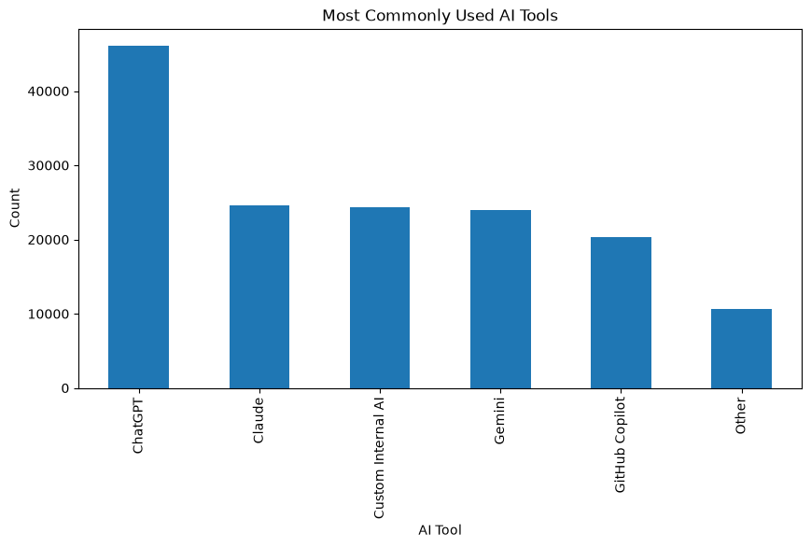

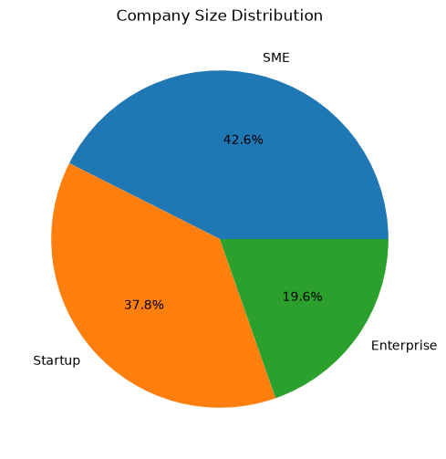
The dataset consisted of organizational information, AI adoption metrics, productivity indicators, and business performance measures.

4. Phase 2: Descriptive Statistical Analysis
Statistical measures calculated:
- Mean
- Median
- Standard Deviation
- Quartiles
- Percentiles
Key Findings:
- Productivity changes varied among organizations.
- AI adoption rates showed differences across industries.
- Employee satisfaction and revenue growth exhibited measurable variation.
- Company size distribution was analyzed.

! 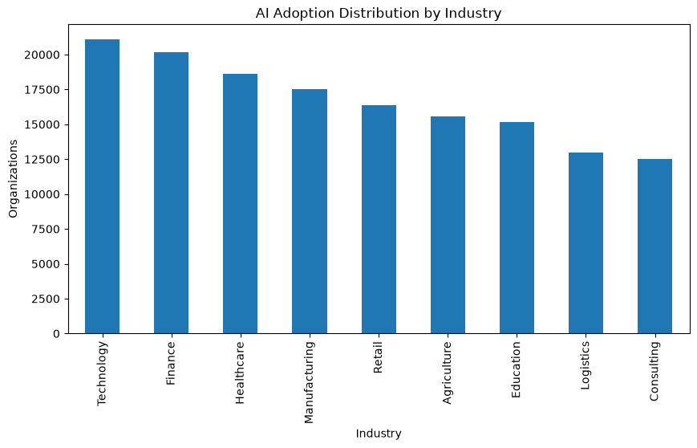

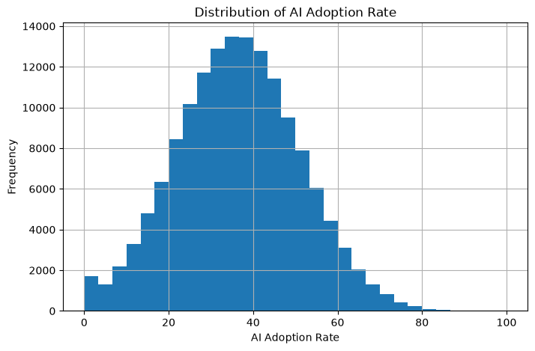

5. Phase 3: Trend Investigation
Industry vs Adoption
AI adoption rates were compared across industries.
Company Size vs Adoption
AI adoption patterns were analyzed among Startups, SMEs, and Enterprises.
AI Tool vs Satisfaction
Employee satisfaction levels were compared across AI tools.
Adoption Year vs Growth
AI adoption growth trends were examined over time.
Employee Count vs AI Usage
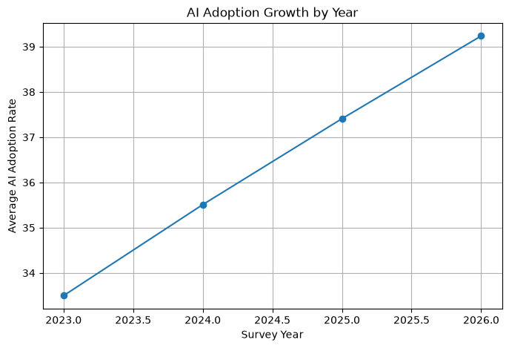
The relationship between organization size and AI adoption was analyzed.

Findings
- AI adoption trends differ across industries.
- Larger organizations generally demonstrate stronger AI adoption.
- Employee satisfaction varies depending on AI tool usage.
- AI adoption has increased over time.

6. Phase 4: Correlation Analysis
Relationships Studied:
- Adoption vs Productivity
- Tool Usage vs Satisfaction
- Employee Count vs Adoption
- AI Investment vs Savings
Findings
- AI adoption shows a positive relationship with productivity.
- Employee satisfaction is associated with productivity outcomes.
- Larger organizations tend to adopt AI at higher rates.
- AI investment contributes to operational savings.
Questions Answered
Does AI adoption improve productivity?
Yes. Organizations with higher AI adoption rates generally demonstrate improved productivity.
Do larger organizations adopt AI faster?
Yes. Enterprises generally exhibit higher AI adoption levels compared to Startups and SMEs.
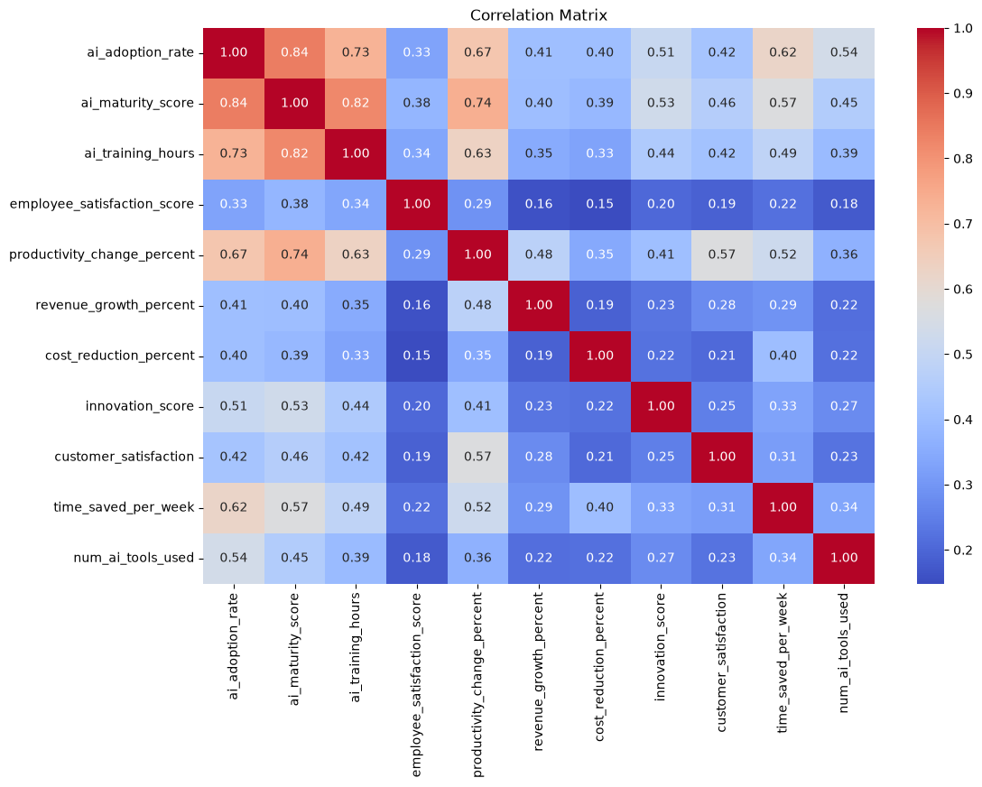

7. Phase 5: Hypothesis Testing
Test Used
One-Way ANOVA
Null Hypothesis (H0)
Company size has no impact on AI adoption.
Alternative Hypothesis (H1)
Company size significantly impacts AI adoption.
Results
F-Statistic = 3746.05
P-Value = 0.0
Decision
Since the p-value is less than 0.05, the null hypothesis is rejected.
Business Interpretation
Company size significantly impacts AI adoption. Enterprises generally possess greater resources, infrastructure, and investment capacity to implement AI technologies compared to smaller organizations.

8. Phase 6: Organization Segmentation
Organizations were segmented into:
- AI Leaders
- Early Adopters
- Slow Adopters
- High Satisfaction Organizations
- High ROI Organizations
Findings
- AI Leaders demonstrate higher productivity and business performance.
- Early Adopters show promising growth in AI implementation.
- High Satisfaction organizations report better workforce acceptance.
- High ROI organizations achieve greater cost reductions
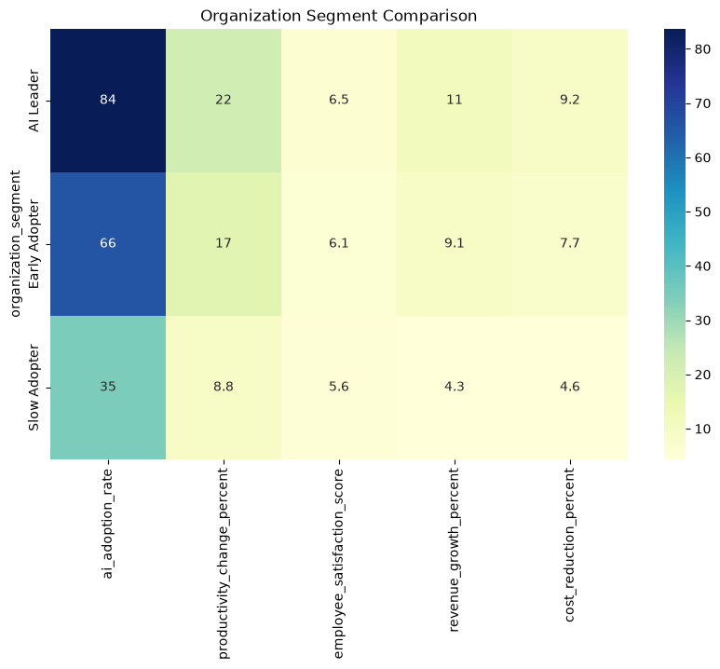

9. Business Insights
- AI adoption positively influences productivity and operational efficiency.
- Company size plays a significant role in AI adoption.
- Employee satisfaction contributes to successful AI implementation.
- AI investments generate measurable business benefits.
- Industry-specific differences influence adoption patterns.

10. Recommendations
- Increase AI adoption among low-performing organizations.
- Provide employee AI training programs.
- Invest in high-impact AI tools.
- Support SMEs and Startups in AI transformation initiatives.
- Continuously monitor productivity and AI performance metrics.

11. Future Scope
- Develop predictive models for AI adoption forecasting.
- Apply machine learning techniques to predict organizational performance.
- Perform industry-specific AI maturity analysis.
- Build interactive dashboards for real-time AI monitoring.

12. Conclusion
This project successfully analyzed AI adoption trends using statistical analysis, correlation analysis, hypothesis testing, and organizational segmentation. The results indicate that AI adoption contributes positively to productivity, operational efficiency, and business performance. Organizations that strategically invest in AI can achieve measurable improvements in growth and competitiveness.

